**Run locally and Practice PHP**

**Step1:** *Starting with PHP*

Practice:

a. Go to your document root /xampp/htdocs/

b. Create folder called ‘PhPpractice’

c. create a file called ‘test.php’

d. insert the following code in the ‘test.php’ file

<html>

<body>

<?php

echo "MY First PHP Program";

?>

</body>

</html>

e. Start Apache server from XAMMP control panel, because we need a webserver to run the PHP code.

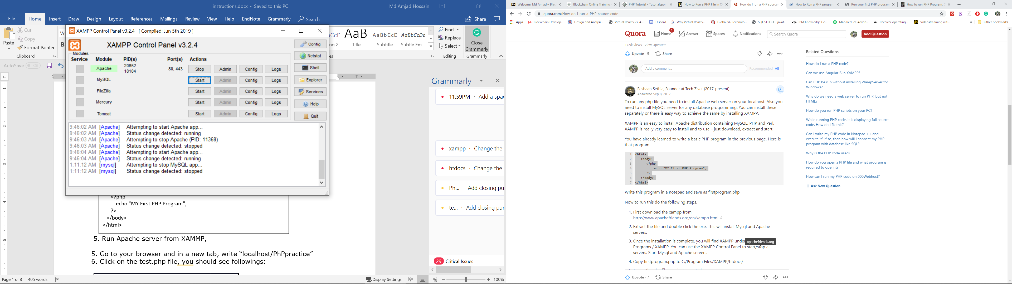

f. Go to your browser and in a new tab, write “localhost/PhPpractice”

g. Click on the test.php file, you should see followings:

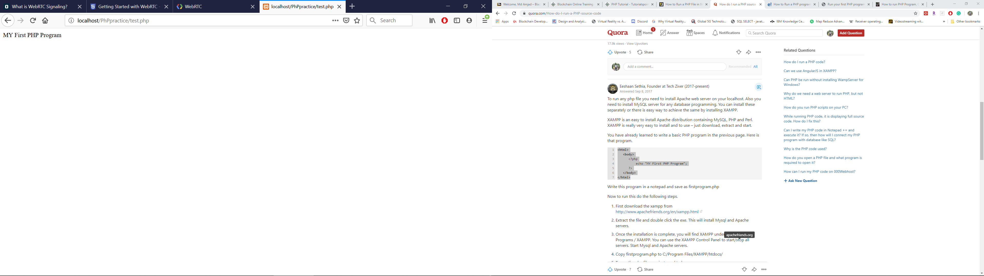

**Step2**

You should practice some HTML and PHP codes. Here are some links you should go and try to understand W3Schools.com

a. <https://www.w3schools.com/php/php_syntax.asp>

b. <https://www.w3schools.com/php/php_forms.asp>

c. <https://www.w3schools.com/php/php_mysql_connect.asp>

d .<https://www.w3schools.com/php/php_mysql_create.asp>

e. <https://www.w3schools.com/php/php_mysql_select.asp>

Now try to understand and execute the code provided in “PhP_practice” folder on Blackboard. You should learn get and post methods from here.